Kol Simcha Torah Gazette
For parshas vayeishev 5785
Volume 9 Issue 13 (Whole #427) 20 Kislev 5785/ December 21, 2024
Printed L’illuy nishmas Nechama bas R’ Noach, a”h

For a free subscription, please forward your request to keren18@juno.com
Past emails can be found on the website ShabbosStories.com under Brooklyn Torah Gazette

The Challenge of Overcoming Our Personal Yetzer Hora
By Daniel Keren

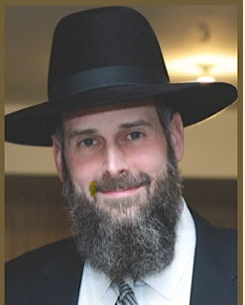
Rabbi Yosef Viener

One of the featured speakers at the recent Flatbush Thanksgiving Day Hakhel Yarchei Kallah Event was Rabbi Yosef Viener, mora d’asra of K’hal Sha’ar Hashomayim in Monsey. The topic of his shiur was “Tax Returns, Investment Returns and Priceless Returns: An Honest Perspective.”
Rabbi Viener said that it is very human that every person has their own interests and agenda. Our purpose in life is to drop these selfish considerations and ask ourselves what does Hashem truly want of us. Hashem put us into a world with a few billion people. The Yetzer Hora, our evil inclination, tries to convince us that we do want things for free, whereas our Yetzer Tov, our good inclination, teaches us that we really want to earn our spiritual schar, reward.
Our Desire to Return to Hashem
Rav Shimshon Pincus taught that every Yom Noraim (Rosh Hashanah and Yom Kippur) and Tanais, fast day, in our prayers and selichos we recite the pasuk, verse – of our desire to return to Hashem [bi’teshuva, repentance.]
Rabbi Viener noted that one usually doesn’t wake up in the morning with the Yetzer Hora asking a frum (religiously observant] Jew to do a major aveira, sin (i.e. eating a ham and cheese sandwich) during the course of a day. Rather during the course of a day, the Yetzer Hora throws a person off balance and this results in a Yid losing his kavanah, concentration when davening, praying or performing other mitzvahs.
Hashem tells us, Rabbi Viener said, that our thoughts are not His thoughts. This tell us that in most of our lives, we will not know the reasons why certain difficulties pop up in our lives.

No Comparison Between the Understanding
of a Three-Year-Old Child and His Father
Rabbi Viener gave the example of an adult and his three-year-old child who are looking out of a window at the same time. There is absolutely no comparison to what the child comprehends and to what his father understands. Yet what the parent understands is even less when compared to Hashem’s comprehension, similar to the difference between shomayim (the heavens) and ha’aretz (the earth.)
When it comes to asking Hashem about why certain things happen in our life or to other people, we will never really understand. Hashem wants us to be very good in the concept of giving others the benefit of a doubt. We are here to practice our midos and be more aware of Hashem and emulate Him by becoming more of a rachum, compassionate person in regards to others who are in pain and are suffering.

A Never-Ending Task in the Life of Every Person
Intellectually, Rabbi Viener said, we understand that everything that Hakodesh Baruch Hu does to us is for our best. Nevertheless, we have to work very hard to make this belief a reality, a never-ending task in the life of every person. Hashem causes things to occur in our lives that are painful afflictions in order to cause us to reflect on what Hashem wants us now to do. Whenever Hashem gives a person unwanted pressures or difficulties, it is because Hashem is giving each and every one of us a precious opportunity for spiritual growth.

No Clear Bottom Line in Spiritual Matters
An accountant wants to know the bottom line. Are we making money? Or are we losing money? But in spiritual matters, Rabbi Viener said, we do not have a clear bottom line. Even when one does a mitzvah, he may be rewarded for only 80% of the good deed, because the other 20% of the Torah precept was not done properly.
When reflecting on a mitzvah that one does perform, we have an obligation to pat ourselves on the back in order to give ourselves the inspiration to continue in the future doing similar mitzvahs. On the other hand, we should, Rabbi Viener emphasized, reflect on that mitzvah and honestly ask ourselves if we could have done that Torah commandment in perhaps a better manner.

Reprinted from this week’s edition of The Jewish Connection.

Rav Avigdor Miller on
What Does Hakadosh Baruch Hu Want Us to Be ?
Chassidish or Litvish or…

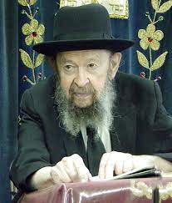

Now that’s some big order. He wants me to make enemies, the one asking this question.
Hashem wants you to be the best that you can be. Some people can be their best if they’re Chassidish. Some people can be their best if they’re Litvish. Other people can be their best if they’re Sefardi. You have to figure out for yourself what will help you be the best. And you have to really think about it.
And therefore, it’s like asking – “What is the best diet for all of mankind?” The best type of diet depends on each individual person. People are different. Some people are so different that their diets are radically different.
So, whatever it is that you choose, you should make it a principle in your life to always choose whatever it is that will give you the most success in life – and success in this world means preparing for the Next World.

Reprinted from the Parshas Vayishlach email of Toras Avigdor, - July 1979

Thoughts that Count
for Our Parsha

These are the generations of Jacob, Joseph (Gen. 37:2)
The name Joseph (Yosef) comes from the Hebrew meaning to add or increase. Jacob is symbolic of every Jew. The lesson to be derived is that a Jew must never allow himself to stagnate, but must always climb upward along the spiritual "ladder" of Yiddishkeit. (Rabbi Menachem Mendel of Riminov)

And they hated him, and could not speak peaceably to him (Gen. 37:4)
The main component of all controversy is the absence of dialogue, the unwillingness to listen to what someone else has to say and understand it from his perspective. If people would really know how to talk to each other, most of the time they would discover that they have nothing to argue about. (Rabbi Yonatan Eibeschitz)

In my dream, behold, a vine was before me (Gen. 40:9)
Why did Joseph interpret the chief butler's dream optimistically, whereas the chief baker's dream received a negative interpretation? The chief butler had dreamt about the fruits of the Land of Israel, which are the handiworks of G-d rather than of man. The chief baker, by contrast, dreamt about baked goods, which are made by man and symbolize an arrogant attitude of "my strength and the strength of my hands." Such a dream, Joseph figured, could not bode well for the future. (Nahar Shalom)

Reprinted from the Parashat Vayeishev 5762/2001 edition of L’Chaim.
The Importance of a Jew Never Taking a Break in One’s Climb
Up the Spiritual Mountain
From the Teachings of the Lubavitcher Rebbe
Rabbi Menachem Mendel Schneerson, Zt”l



In this week's Torah portion, Vayeisheiv, the Torah narrates the story of Judah and Tamar. "And it was told to Tamar, saying: 'Behold, your father-in-law is going up to Timnah.'"
Why is it important for us to know that Judah was "going up" to Timnah? Why doesn't the Torah simply inform us that Judah was "going"?
As noted by Rashi, the foremost Torah commentator, in a later book of the Bible where the name of the city again appears, the association is one of descent rather than ascent. "And Samson went down to Timnah." From this we derive that Timnah was located on the slope of a mountain. A person approaching Timnah from below had to climb up; anyone approaching it from the top of the mountain had to walk downwards. When Tamar was told that her father-in-law was going up, it indicated which direction he was coming from.
When ascending a mountain, it is not a good idea to pause in mid-climb. Neither is a mountain slope an appropriate place to stop and rest. If a mountain climber stops in the middle, not only is he likely to lose momentum, but he also risks losing his footing and falling backward. When a person is headed upward, he must always go forward and persevere.
A Jew's Divine service is likened to climbing a mountain, as it states, "Who will ascend the mountain of the L-rd." When it comes to spiritual matters, one cannot be sluggish or take "time off." An individual who declares himself satisfied with the spiritual level he has already attained and does not strive for even higher levels will eventually lose his footing and tumble, like the mountaineer who decides to take a break in the middle of his climb.
When engaged in the service of G-d, it is impossible to remain in the same place. One must always make an effort to go from strength to strength. Merely "treading water" on the same level ultimately leads to spiritual regression and decline; lack of upward movement invariably results in a downward trend.
During Chanuka, it is customary to light an additional candle each night of the holiday, according to the principle of "increasing in holiness." If one evening we were to kindle the same number of lights as the previous day, it would indicate a state of spiritual decline or regression.
In matters of holiness, we must never content ourselves with yesterday's achievements. For the service of G-d requires perpetual upward motion.

Reprinted from the Parashat Vayeishev 5762/2001 edition of L’Chaim, a weekly publication of the Lubavitch Youth Organization in Brooklyn, NY. Adapted from Volume 10 of Likutei Sichot

The Dream and Yosef’s Brother

“Yosef dreamt a dream which he told to his brothers, and they hated him even more.” (37:5)
Why did Yosef tell his brothers his dream? Couldn’t he have foreseen the consequences? R’ Aharon Yehuda Leib Steinman z”l (1914-2017; Rosh Yeshiva in Bnei Brak, Israel) answers:
Clearly this was part of the Divine plan. Our Sages say, “Dreams follow their interpretation,” i.e., that the interpretation given to a dream impacts whether and how it will come true. Here, Hashem wanted Yosef’s brothers to hear his dream and declare (37:8), “Would you then reign over us?!”
Alternatively, R’ Steinman writes: It is said that if a person could travel to distant stars, his experience would be incomplete until he came home and told someone about it. Perhaps Yosef, too, was so moved by his dream that he needed to tell someone about it. (Ayelet Ha’shachar)
Reprinted from the current Parashat Vayeishev 5785 email of Rabbi Yedidye Hirtenfeld’s whY I Matter parshasheet for the Young Israel of Midwood in Brooklyn.
Rabbi Berel Wein on
Parshat Vayeshev 5784

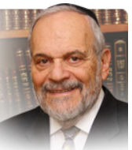

Yosef feels the brothers have been unjust for rejecting his dreams immediately and they in turn are convinced that he and his dreaming constitute a veritable danger to the unity and survival of Yaakov’s family. It is not only the contents of Yosef’s dreams – that he will dominate the family – that disturb the brothers. It is the very fact that he is dreaming that raises their suspicions and fuels their enmity towards him.

In the struggle between Yosef and the brothers, the conflict is between the lofty and inspirational theory of Judaism and its sometime mundane practice of hope and actual reality of what can be achieved even though it is not exactly what one dreamt of achieving. The conflict between Yosef and his brothers is never really ended. It is compromised by both sides, recognizing the validity of the position of the other and living with that reality.

The Jewish people in its long and difficult history have somehow been able to combine the spirit and dreams of Yosef with the hardheaded realism of his brothers. Both traits are necessary for our survival and accomplishments, both as individuals and as a nation. Someone without dreams and ambition, who refuses to reach heavenward and conquer the stars, will never be a truly creative or original person.

But if this drive is not tempered by a realistic sense of the situation and the society that surrounds us, then all dreams are doomed to eventually disappoint. Yosef’s dreams are realized only after he has been severely chastened by his brothers’ enmity, slavery and imprisonment in Egypt. Even after he seemingly has them in his grasp, it is still a contest of wills. Again, Yosef’s dreams are finally realized but only after he has been subjected to many hard years of unpleasant reality.

The brothers, realists to the end, are shocked to see that the dreamer has emerged triumphant. The dreamers save the world from famine while the realists end up being its customers. Thus, the Torah teaches us that we need both dreamers and realists within our ranks. A nation built exclusively on dreams, without practical reality intruding, will find that reality rising to foil the realization of the dream.

A nation that ceases to dream of reaching greater heights will stagnate and not survive. So, both the brothers and Yosef are “right” in their pursuit of building a nation and of spiritual growth. We need a healthy dose of both values and views in our Jewish world today as well.

Reprinted from the current website of rabbiwein.com

It Once Happened
“Va’ani Ana Ani Ba”
(And I, Where Will I Go?)

Avraham Pinchas lived 100 years ago in Baghdad. The wealthy Jewish merchant usually had a table full of guests, but this Shabbat he only had one, a poor man he had invited home from the synagogue. The guest was awed by the plush richness around him: the thick Persian rugs, gold inlayed dishes and beautifully decorated walls. Only one thing perplexed him: in the middle of the table stood an old, empty, broken bottle that looked as if it had once contained olive oil.
When Mr. Pinchas noticed his guest's interest in the odd artifact, he told him the following story.
"My father was a respected businessman, but he was always busy and left me in my grandfather's care. Every morning my grandfather would wake me, make sure I washed my hands, said the morning blessings and didn't forget my lunch. Then just before I left for school, he would give me a kiss on my forehead, raise his hands and say, 'Va'ani ana ani ba' ['And I, where will I go?' (Gen. 37:30)]. Later, I learned that this is what Reuven cried out when he discovered that Joseph was no longer in the pit and it was impossible to save him. But I had no idea why my grandfather always said that.
"Then, when I was 14 years old, tragedy struck: my grandfather passed away. I began to accompany my father to work. My father tried to make sure that I prayed and studied Torah but he was always very busy. I was so fascinated by his business that I didn't pay much attention to my studies.
"Two years later, my father died suddenly. Besides the fact that I was now alone, I had to decide what to do with the business. I was given the choice of selling it, or trying my luck as a manager. Against the advice of lawyers, I chose the latter.
"Well, I took to it like a fish to water. It wasn't long before I was quite successful. But I began to feel out of place as an observant Jew. I felt that keeping Shabbat and eating kosher prevented me from expanding my business. Slowly but surely, I became less observant, and I discovered that the more commandments I dropped, the more successful I became.
"Several years passed. One day I was walking in the street when I noticed a Jewish boy, maybe 13 years old, sitting on the sidewalk crying. I asked him what was wrong. 'Oh, thank you, sir,' he said 'but this is something only Jews would understand.'
"His words stabbed me in the heart. 'I am also Jewish...' I stammered.
"'Oh, I'm sorry,' he answered, 'I didn't mean to offend you. It's just that I'm very sad about my home situation. We are very poor...' The boy looked up at me and wiped his eyes with his shirtsleeve. 'My father died a while ago and my mother works hard to support my six brothers and sisters. Well, this morning my mother told us that tonight is Chanuka.
“We prayed for a miracle, that we might find some money with which to buy oil. We were so happy when my sister found a coin behind a drawer! I ran right to the store and bought a small bottle of oil. I was walking home, holding the bottle and dreaming about Chanuka. I was even imagining that Moshiach might come now, and my mother will start to smile again. Unfortunately, I wasn't looking where I was going, and I tripped. I watched in horror as the bottle flew from my hands and landed on a stone. It broke, and all the oil spilled out. 'Va'ani ana ani ba!' With these words, the boy began to wail.
"At that, I suddenly realized what my grandfather had meant. He must have known that this would happen. That broken bottle is me! And the spilled oil is my Jewish soul - I've lost my Jewish soul!
"As if in a trance, I withdrew some money from my pocket and handed it to the boy. 'Go back to the store,' I told him. 'Buy what you want, and have a happy Chanuka! Go!'



"When the boy was gone, I carefully picked up the bottle and carried it home, still in shock. I sent the servants away and when I was alone, I just stood there, looking at it and weeping. Then the thought struck me, 'A Jew can't lose his Jewish soul.' Maybe I had ignored it for a while, but I'm sure it's still there. I took my grandfather's menora out of the cabinet, dusted it off, found some oil and a wick and lit the first Chanuka candle.
"Its light made me feel alive again. I even decided that the next morning I would begin putting on tefilin. The following night I lit two candles and decided that from now on I would eat only kosher. The third night, I decided to begin learning Torah. The night after that I made the decision to keep Shabbat. By the end of Chanuka I had become a new man. A renewed man. The Chanuka lights had saved me.
"So that is the reason I keep that broken bottle: to remind me how the miracle of the oil saved my life."

Reprinted from the Ohr Tmimim Newsletter, www.ohrtmimim.org

******************************************************************

And Joseph went into the house to do his business (Gen. 39:11)
According to the Targum (translation into Aramaic) of Onkelos, Joseph went in to "examine the accounts" (for which he was responsible) of Potiphar's household. Indeed, this was the greatness of Joseph: the ability to maintain the highest level of attachment to G-d even while actively involved in worldly pursuits. (Derech Mitzvotecha)

Reprinted from the Parashat Vayeishev 5762/2001 edition of L’Chaim.
Melbourne Synagogue Fire
By Jeff Jacoby

One of the Oldest Evils Perpetrated Against Jews

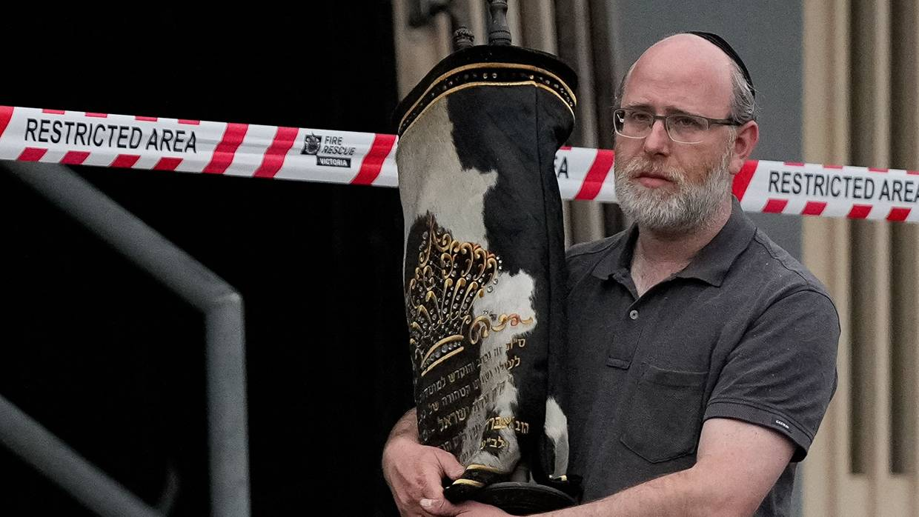
As overt antisemitism becomes increasingly normalized, the hate crimes will continue to pile up.

Shortly after 4 a.m. on Friday, two people in masks were spotted dousing the main entrance of the Adass Israel Synagogue in Melbourne, one of Australia’s largest and busiest shuls, with gasoline. Moments later, the building was set on fire and rapidly became an inferno. At that very early hour, only a few men were in the sanctuary; they had come to study before morning prayers began two hours later.
They realized what was happening when they heard glass shattering and were able to get out of the building through a rear door, though one suffered burns to his hand and two had to be hospitalized for smoke inhalation. Had the arsonists struck an hour later, far more people would have been inside. There is no telling how many might have died.
The damage was massive. Much of the interior was gutted. Many religious books were turned to ash. It took 60 firefighters and 17 trucks to put out the fire. At least six Torah scrolls — the most venerated objects in Jewish worship; each one typically takes 12-18 months to write — were damaged by heat and water.

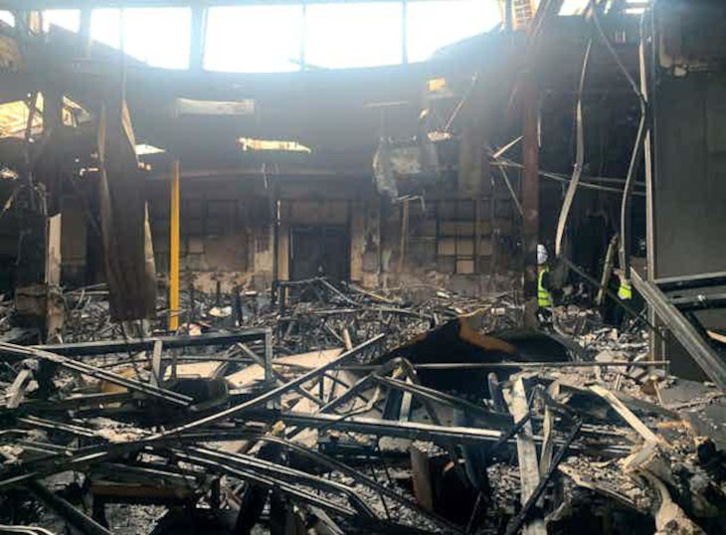
Inside the Adass Israel synagogue

Adass Israel was founded after World War II. Many of its first congregants were European immigrants who had survived the Holocaust. Rebuilding their lives following the Nazi nightmare in which one-third of the world’s Jews were murdered, they would have remembered only too vividly the smashing and burning of synagogues across Germany and Austria in November 1938 — the Kristallnacht pogrom that foreshadowed the genocidal whirlwind to come.
To Jews of that era, born in a world where antisemitic violence and destruction was not only routine but often promoted by political and religious leaders, it would not have come as a bolt from the blue that Jew-hating arsonists would attack a synagogue. Not so for the 21st-century Jews of Melbourne, some of whom naively believed that in civilized societies, such atrocities are no longer possible.

There had been no shortage of reminders for Australia’s Jews, especially since Oct. 7, 2023, that many of their fellow Australians hate them.
“I'm shocked, just absolutely shocked,” Benjamin Klein, an Adass Israel board member, told Australia’s 9News TV network. “We didn't think it will happen here in Melbourne to us. We’re a quiet community. We have our heads down, we don't bother anybody, we wish everybody well.” Klein is an Orthodox Jew, but there was a similar reaction from less religious Australian Jews. Benjamin Preiss, a Melbourne newspaper editor and a self-described “largely secular” Jew, wrote in a column Monday that even as he was covering the burning of the Adass Israel synagogue, “I struggled to believe that anyone in Australia would so brazenly target a place of peaceful prayer. The fact that there were people inside at the time of the attack makes it all the more sickening.”
Yet there had been no shortage of reminders for Australia’s Jews, especially since Oct. 7, 2023, that many of their fellow Australians hate them. Just two days after the worst slaughter of Jews since the Holocaust, a mob of Hamas supporters rallied in front of the Sydney Opera House, waving Palestinian flags and yelling “… “Gas the Jews.”
Last week the Executive Council of Australian Jewry reported that almost 2,100 anti-Jewish incidents had occurred in the 12 months following Oct. 7 — a fourfold increase from the year before. “With a few honorable exceptions,” the council noted, “the response from political and community leaders, university executives, and civil society has been tepid at best. The result has been a ratcheting up of antisemitism from hateful words to steadily more serious hateful actions.”
Such as screaming antisemitic slogans outside Jewish schools. Or vandalizing Jewish homes. Or physically assaulting Jews in the street. Or torching Adass Israel.
The burning of synagogues is one of the oldest evils perpetrated against Jews. Long before there was a Third Reich or a modern state of Israel, those who hated the Jewish people often expressed that hatred by setting ablaze the places where Jews gathered to pray.
The historian Robert Wistrich, in his sweeping history of antisemitism, “A Lethal Obsession,” describes the fourth-century Church father St. John Chrysostom, who “justified the burning down of synagogues” on the grounds that they were “a temple of demons devoted to idolatrous cults, a criminal assembly of Jews … a gulf and abyss of perdition.”
Chrysostom’s contemporary, St. Ambrose of Milan, shared that view. When a synagogue in Mesopotamia was burned down in 388 at the instigation of the local bishop, the Roman emperor Theodosius ordered that it be rebuilt at the expense of those responsible. An outraged Ambrose argued forcefully that the order should be rescinded. No Christian should be punished for burning a synagogue, he declared, since any building where Jews worshiped was “a home of unbelief, a house of impiety, a receptacle of folly which G-d himself has condemned.”
When the First Crusade reached the Holy Land in 1099, recounted Simon Sebag Montefiore in “Jerusalem: The Biography,” they fought not just the ruling Muslims but also the beleaguered and powerless Jewish community. “The Jews sought refuge in their synagogues, but the Crusaders set them on fire,” Montefiore wrote. “The Jews were burned alive, almost a climactic burnt offering in Christ’s name.”
“First, set fire to their synagogues or schools and bury and cover with dirt whatever will not burn.” – Martin Luther
Martin Luther, the central figure of the Protestant Reformation, was one of history’s great antisemites. In an infamous 1543 treatise, “On the Jews and Their Lies,” he offered his “sincere advice” for dealing with “this rejected and condemned people, the Jews.” His list of recommendations began: “First, set fire to their synagogues or schools and bury and cover with dirt whatever will not burn.”
In the Muslim world, too, synagogues have been burned to the ground again and again: in Persia in 1839, in Cairo in 1945, in Algeria in 1956, in Istanbul in 2003, in Damascus in 2013, in Tunisia in 2023, and in numerous other instances.
Even when Jewish communities have ceased to exist, the synagogues they leave behind have been destroyed by arsonists. In 2005, Israel ended its occupation of the Gaza Strip, unilaterally turning over the entire territory to the Palestinian Authority, dismantling the 21 settlements that had been built there and removing the 9,000 Jewish residents who had lived in them. But they left the synagogues intact. The buildings were both sacred and beautiful, and Israelis didn’t have the heart to flatten them. It was thought that even if the former synagogues would no longer be used for Jewish prayer, the Palestinians could put them to good use — as community centers, perhaps, or office facilities, municipal buildings, or schools.
But upon taking over the land that Israel had voluntarily relinquished, the very first thing the Palestinians did was to put the synagogues to the torch. “Gaza's night sky turned orange as fires roared across the settlements,” the Associated Press reported. “Women ululated, teens set off fireworks, and crowds chanted ‘G-d is great.’ ”
What happened last week in Australia has happened in the United States and Canada, too. Congregation Beth Israel in Gadsden, Ala., was firebombed by a Nazi sympathizer in 1960. The similarly-named Beth Israel synagogue in Austin was burned in 2021. A Vancouver synagogue was doused with fuel and set on fire this past May; fortunately, the damage was confined to the front doors and no one was hurt. Six months earlier, Molotov cocktails were hurled at a synagogue in suburban Montreal.
There will be more. As overt antisemitism becomes increasingly normalized, the hate crimes will continue to pile up. More Jews will be menaced and assaulted, more antisemitism will be pumped into social media, more cities will experience “Jew hunts” — and more synagogues will go up in flames. The blood-dimmed tide is loosed, to borrow Yeats’s phrase. Our world is deeply disordered and increasingly out of control. Something truly frightful is coming. Jews, as always the canary in the coal mine, are the first to be targeted. But they won’t be the last.
This op-ed originally appeared in “Arguable,” a weekly newsletter written by Boston Globe columnist Jeff Jacoby.

Reprinted from the current website of aish.com

